1.Create tblcourse

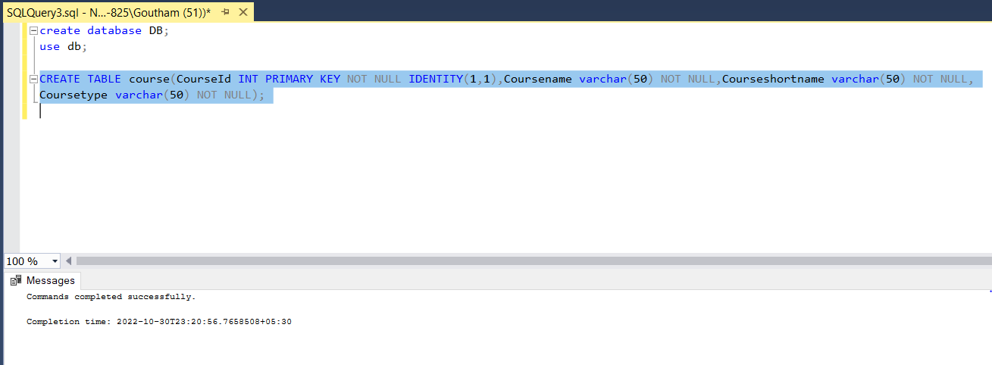

2.Create tblbatch

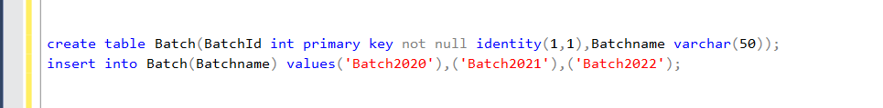

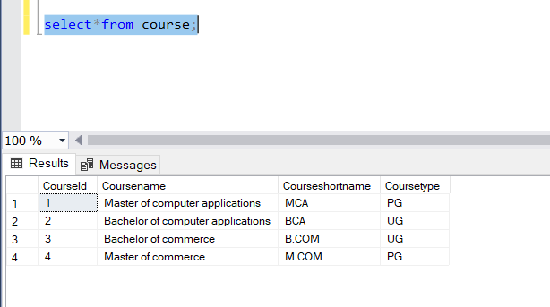

3.Create tblstudent



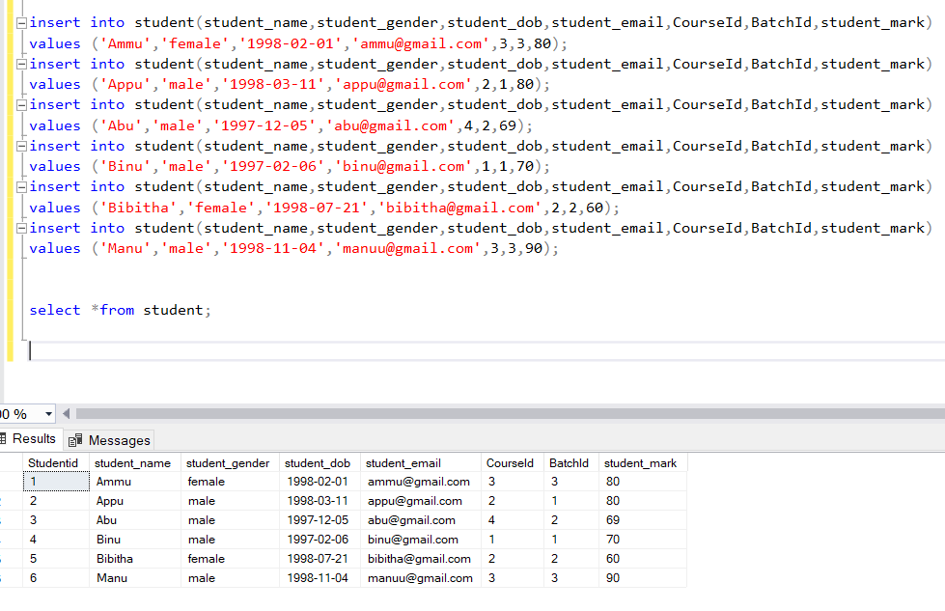

1.Select all the details courses.

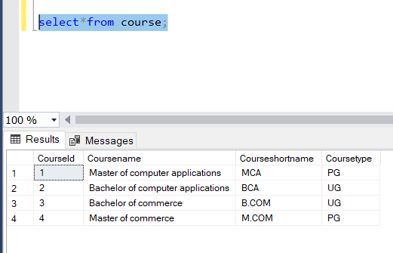

2.Select the name of UG courses

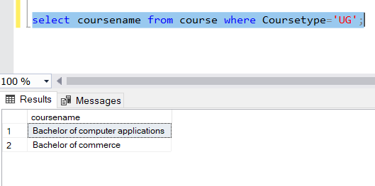

3.Select the name and short name of PG courses

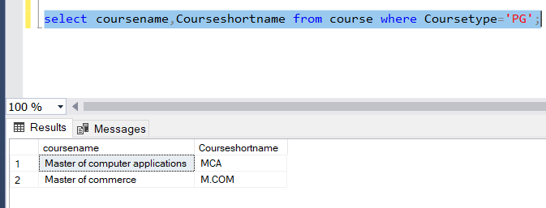

4.Select the details of batches

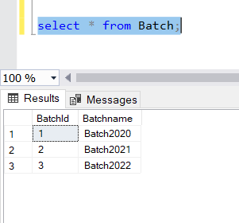

5.Select the details of students

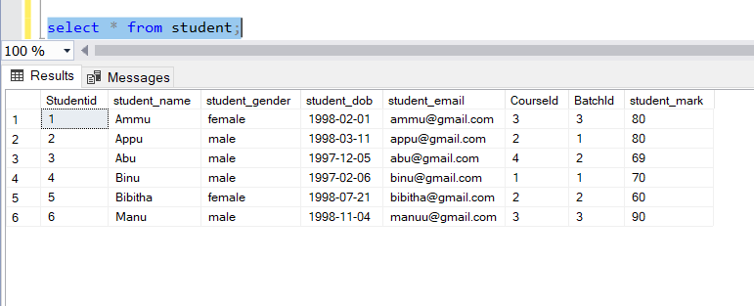

6.Insert 3 students details whose course is MCA or BCA

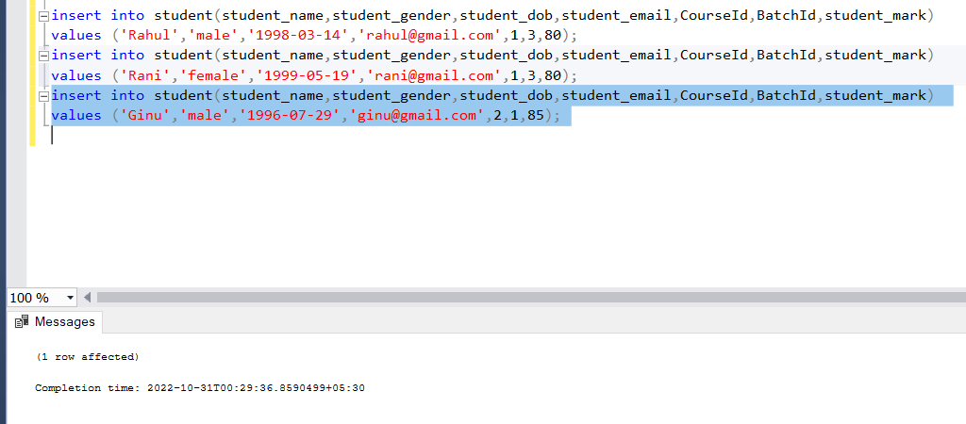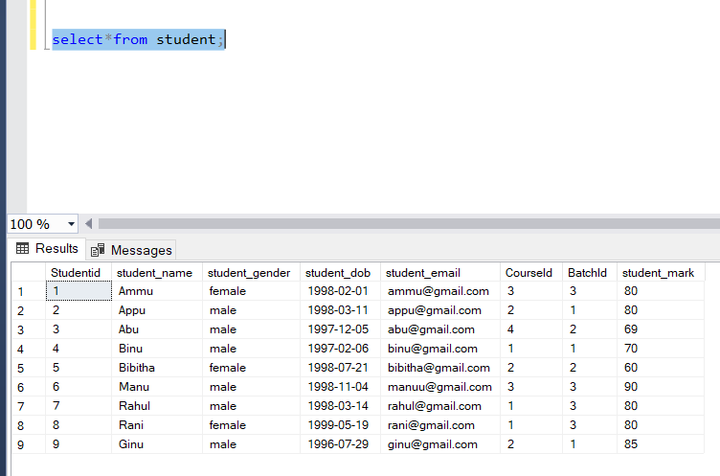

7.Select the count of male and female students(use if case statement)

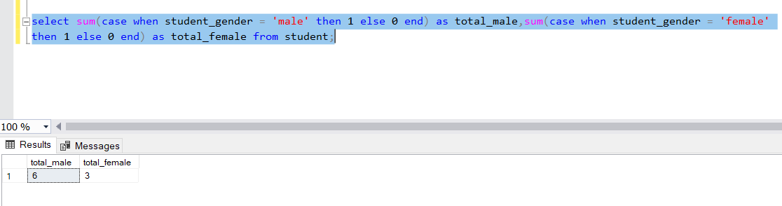

8.Select the details of Female Student.

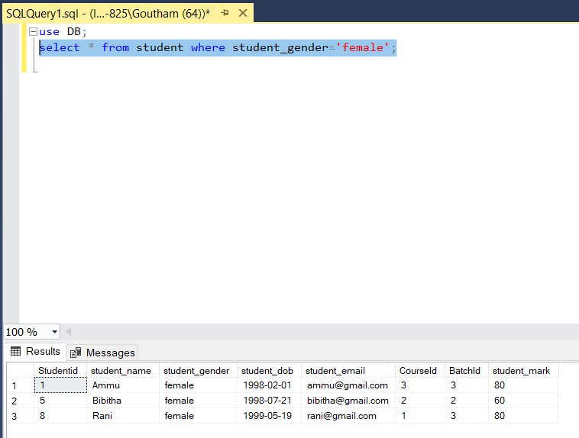

9. Select the details Males students whose course is MCA

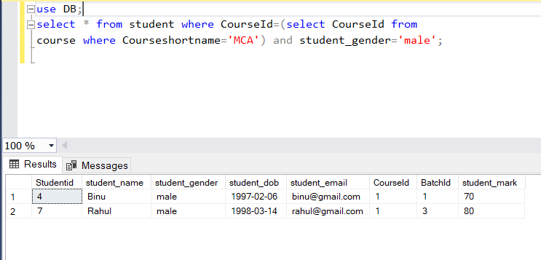

10. Select the details BA Students

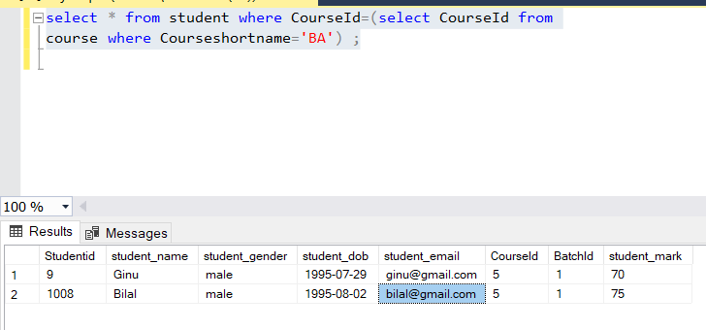

11. Select the details of BA students whose batch is 2017-2018

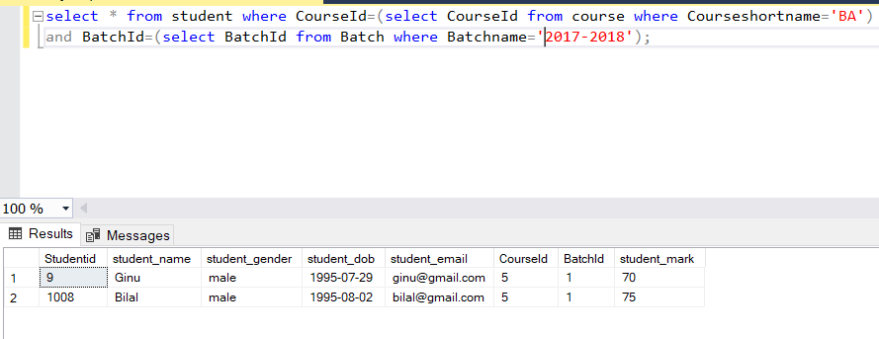

12. Select all the course short name and total number of students

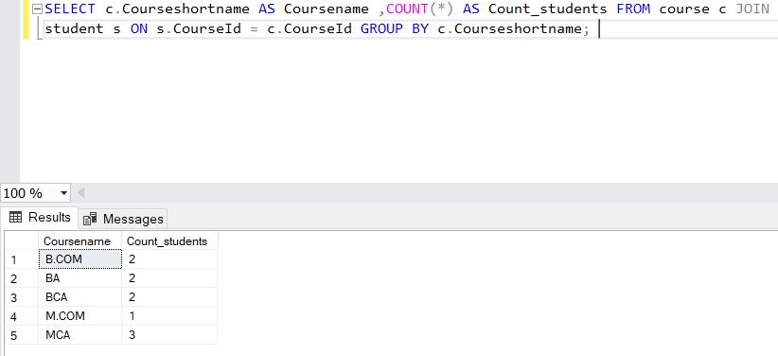

13. Select the details UG Students

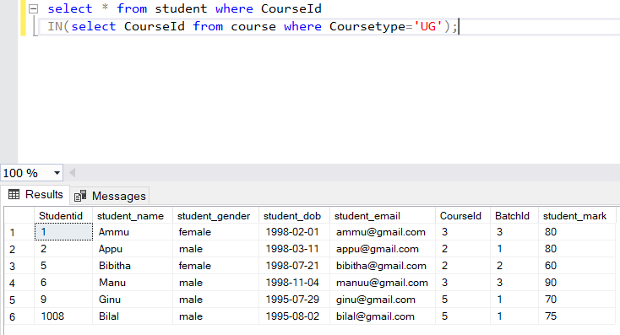

14. Select the details of PG Students

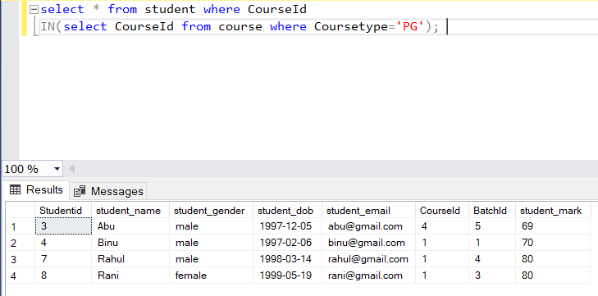

15. Select the details of MCA Students whose batch is 2019-2021

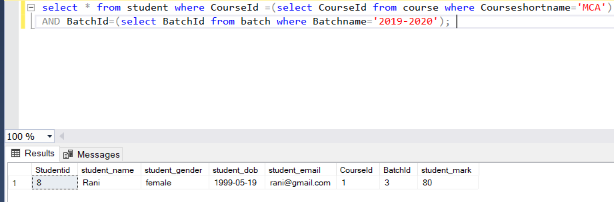

16. Select the email and DOB of BCA Students

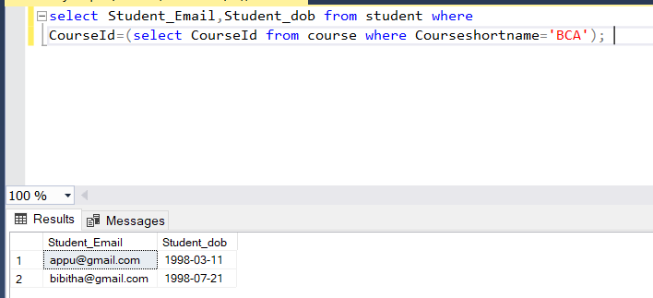

17. Select the students details with their course name and batch name

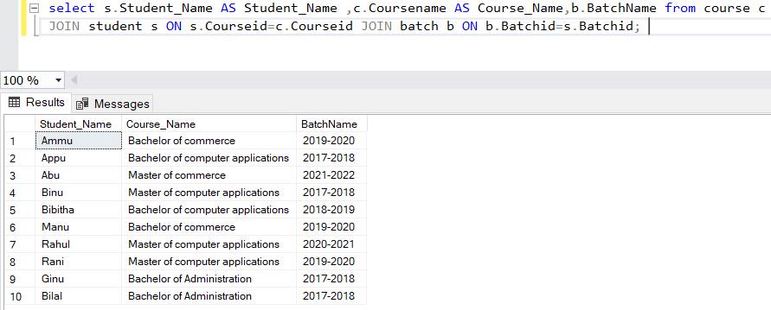

18. Select Batch name and number of students

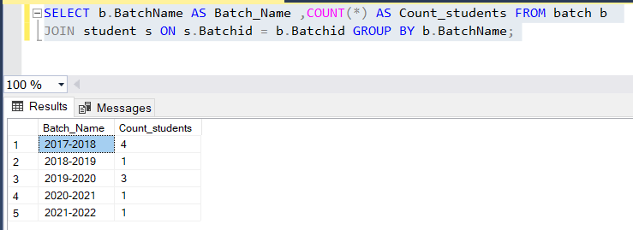

19. Select the students name, course name and students email

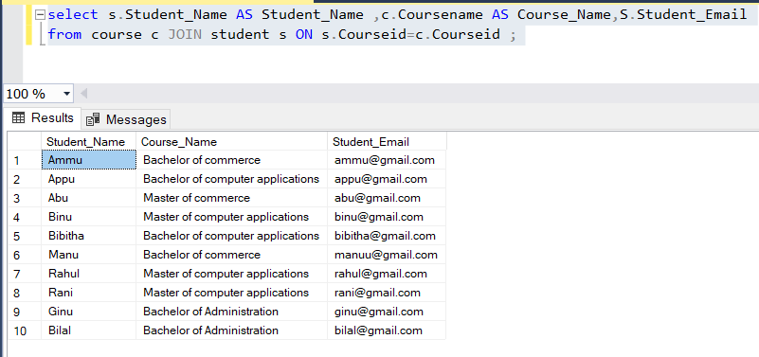

20. Select the Students details and their Batch name also

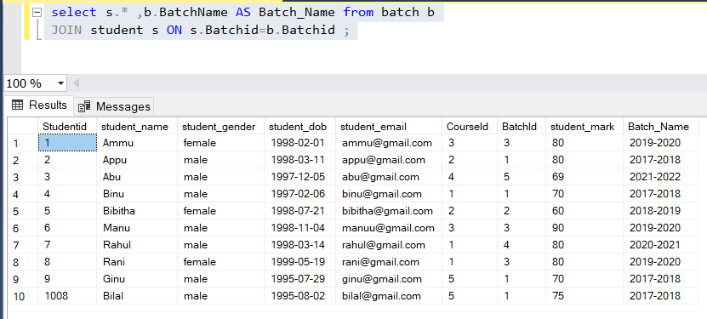

21. Select the count of male and female students in batch wise Sample output

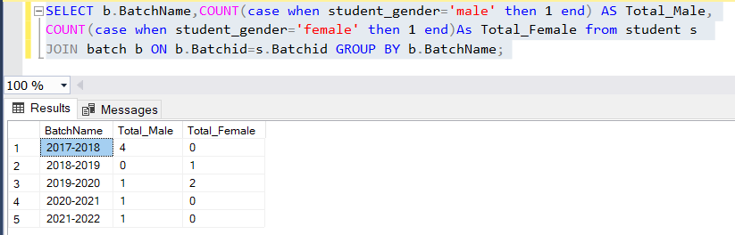

22. Select the name of the BCA Student who have Maximum Mark

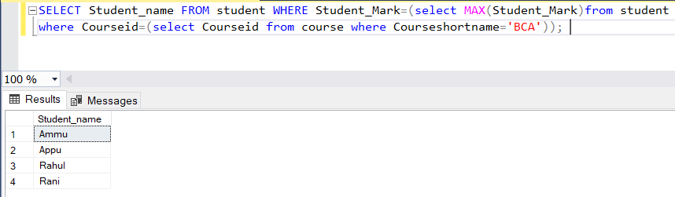

23. Select the Male MCA Student who have Minimum Mark

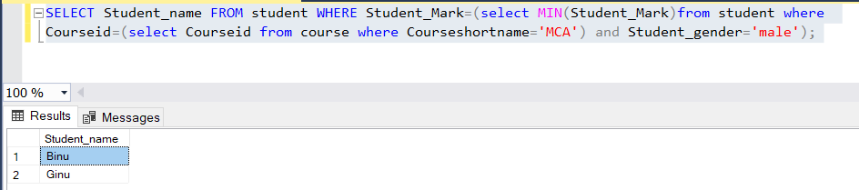

24. Select the students details of UG Students who have greater than the average mark

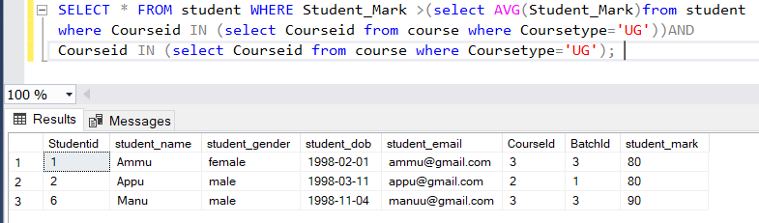

25. Select the BCA student details who have Max Mark

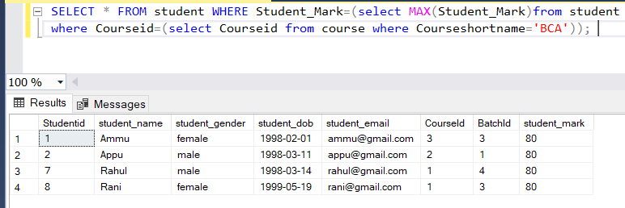

26. Select Name and Email of the students who have second highest mark

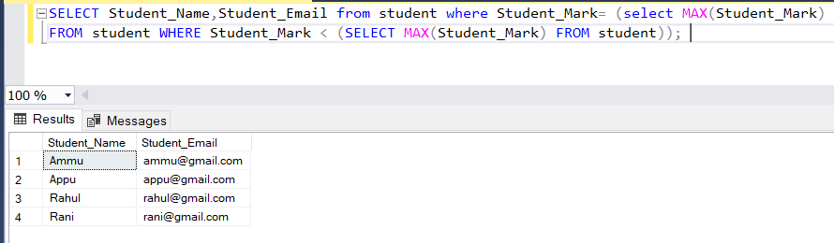

27. Select the Dob and Current Age of All students

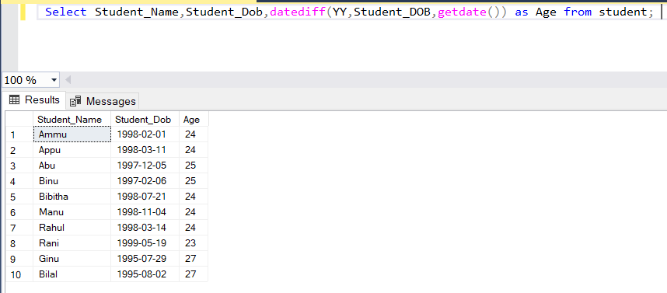

28. Select the Student name , Month name of birth and year of birth for all the students Sample output

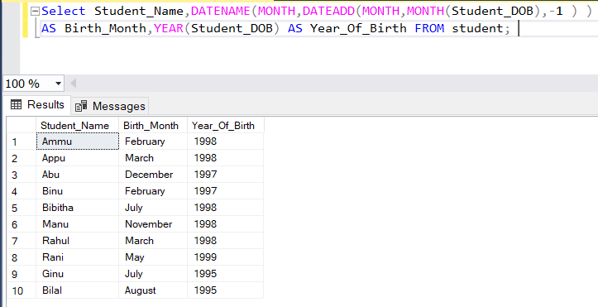

29. Select the Email and Student DOB of MCA Female Student

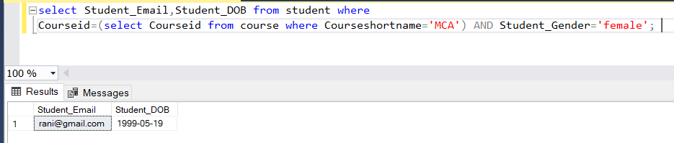

30. Select the name of all the students who have maximum mark in course wise

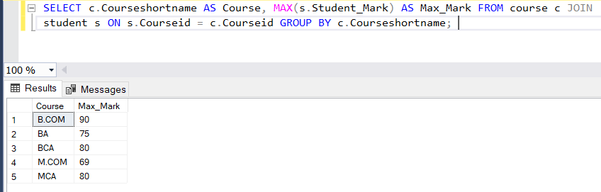

31. Select the Details students whose year of birth less than 1995

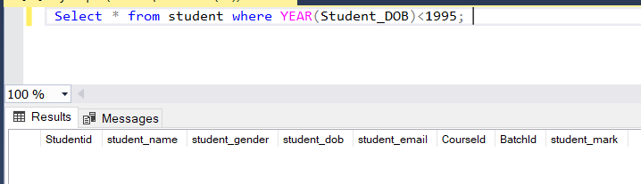32.Select the Course short name, Batch name , total number of students in batch and Course wise Sample

33. Select details of BCA Students whose year of birth between 1992 and 1996

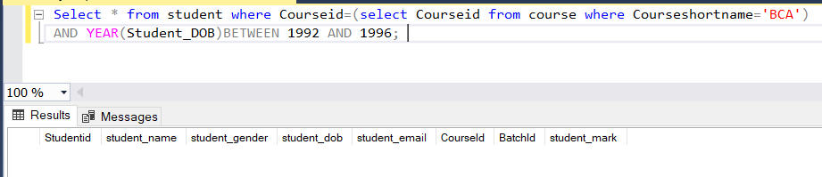

34. Select the details of Male PG Students

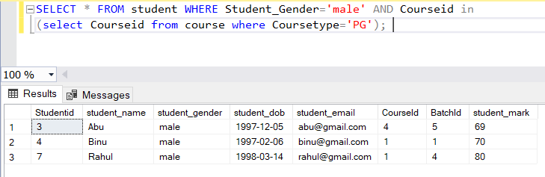

35. Select the details of BCA Students who have greater than average mark

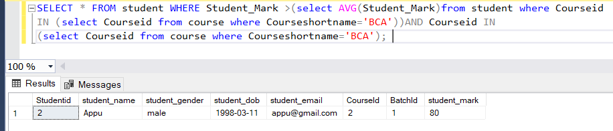

36. Select the name of student having maximum age?

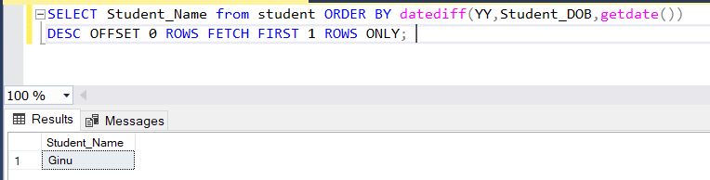

37. Select the name and email of the BCA Students whose have Minimum age

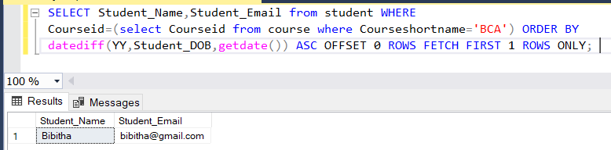

38. Select the details of the students in descending order of their DOB

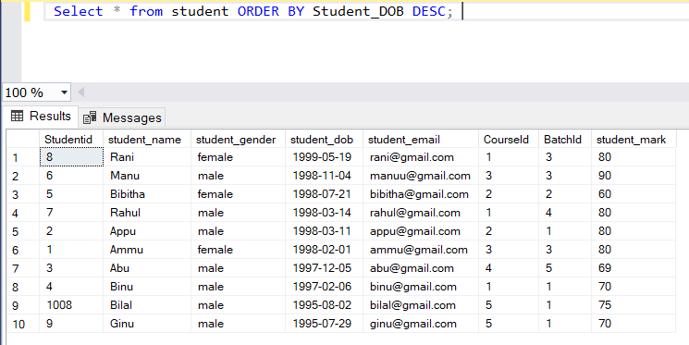

39. Select the details of the students have mark between 65 and 91

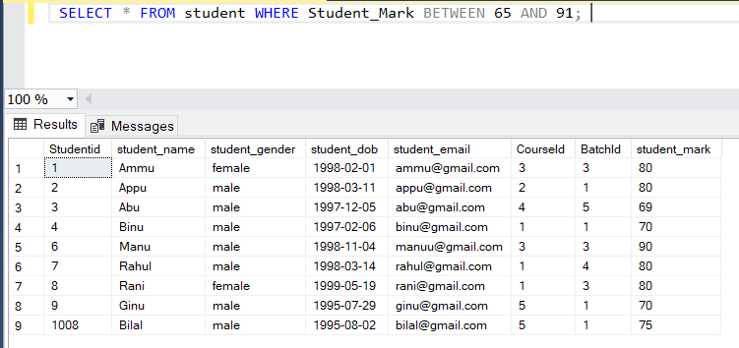

40. Select the details of BCA Students in their mark wise

